**Tenneco Cloud Connector Connection to Subaccount Setup**

Document history

|  |  |  |  |
| --- | --- | --- | --- |
| Version | Date | Description Changes | Writer |
| 1.0 | 04/06/2013 |  | Genteel Balingit |
|  |  |  |  |
|  |  |  |  |
|  |  |  |  |
|  |  |  |  |

Distribution List

|  |  |  |
| --- | --- | --- |
| Company | Name | Version(s) |
|  |  |  |
|  |  |  |
|  |  |  |

Approval

This document requires the following approvals:

|  |  |  |  |  |
| --- | --- | --- | --- | --- |
| Name | Title | Version | Signature | Date |
|  |  |  |  |  |
|  |  |  |  |  |
|  |  |  |  |  |

**Table of Contents**

1. Introduction 4

2. User Guide 4

# Introduction

This document outlines the steps in establishing the Tenneco cloud connector connection to the Tenneco CPI tenant.

The setup of the connection was executed by:

# User Guide

### Initial Steps

Before you begin take not of the following values

1. Region of the Subaccount

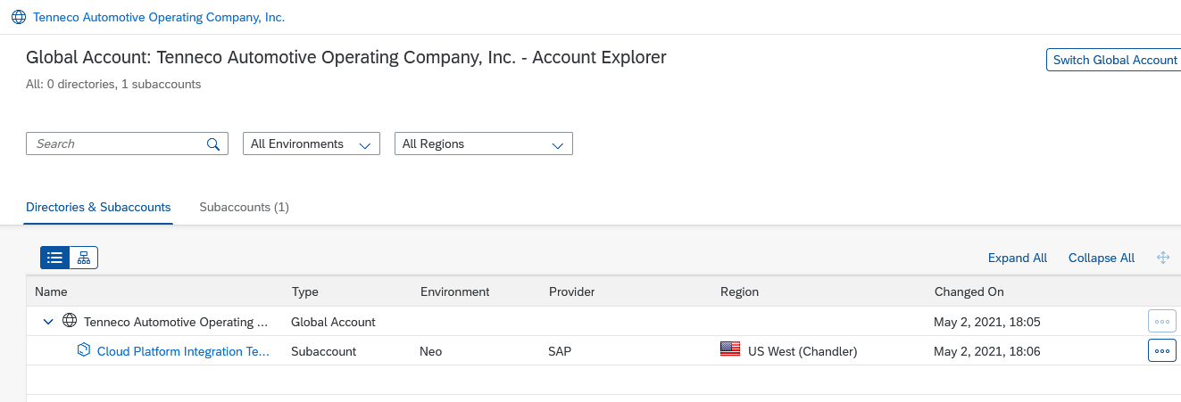

1. User to be used that has a Cloud Connector Admin Role

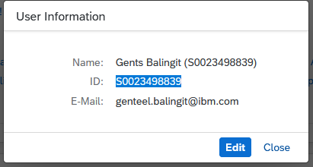

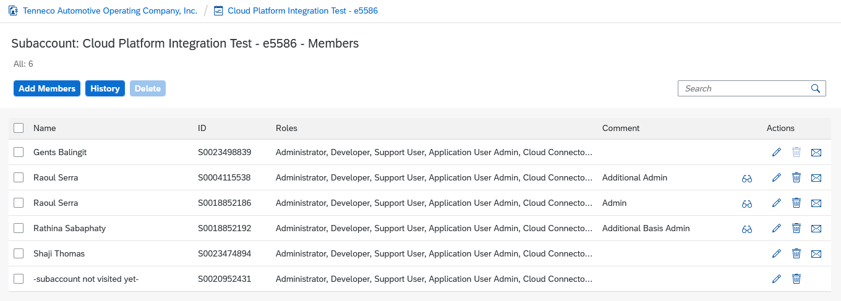

1. Subaccount Technical Name

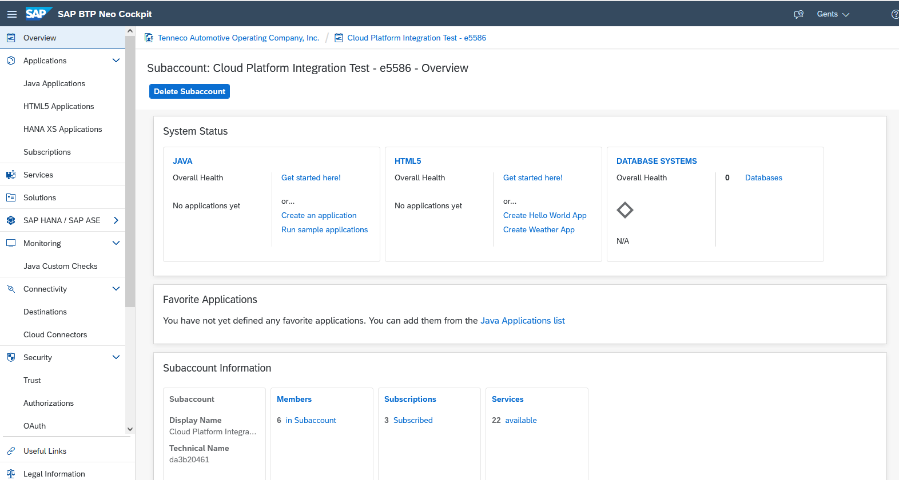

* 1. **Establishing the Subaccount Connection on Cloud Connector**

1. Access the Cloud Connector:

<https://cdcusms256.driv.com:8443>

In the Section define Subaccount enter the values collected above. And click save.

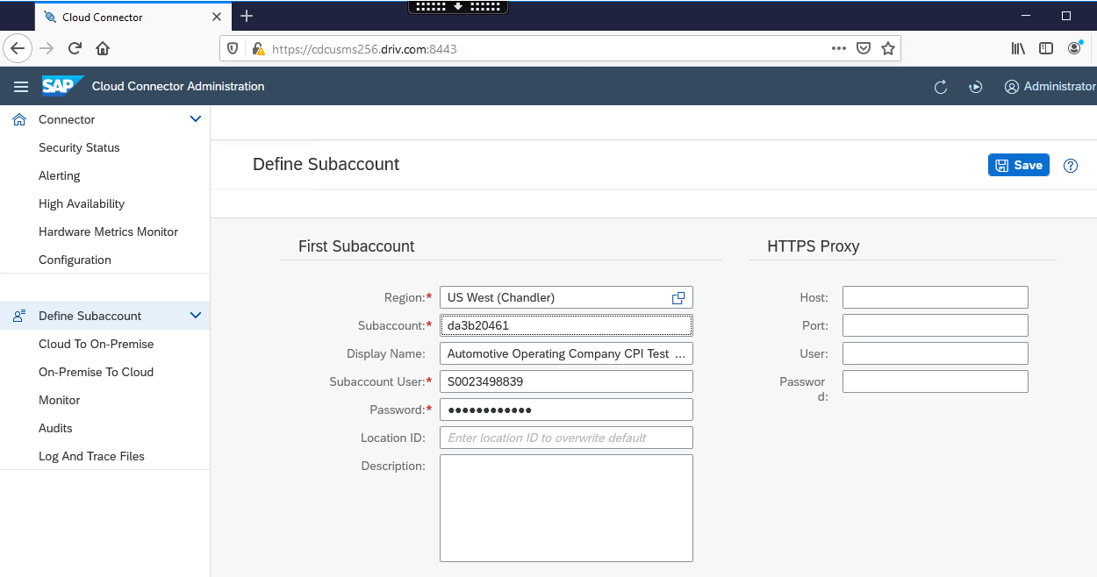

1. Connection to the subaccount should be seen.

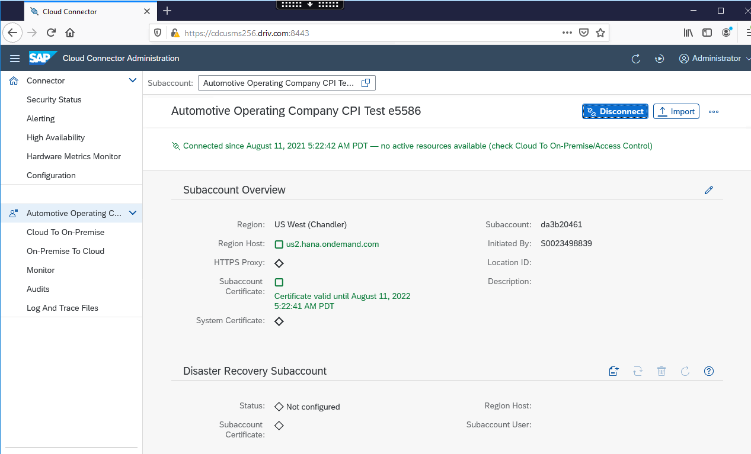

Including the SAP documentation

2461997 - Adding Neo subaccount to SAP Cloud Connector fails due to authorization error